

**Capstone Project Report**

**Report 1 – Project Introduction**

– HoChiMinh City, January 2025 –

**Table of Contents**

[**I. Record of Changes 2**](https://docs.google.com/document/d/1QMCDNXzCgLcDSSwoSlBdBeZ_v7S6Ro1KpyGwjaF0-Hk/edit?hl=vi&tab=t.0#heading=h.8wh1tm67at0x)

[**II. Project Introduction 3**](https://docs.google.com/document/d/1QMCDNXzCgLcDSSwoSlBdBeZ_v7S6Ro1KpyGwjaF0-Hk/edit?hl=vi&tab=t.0#heading=h.uuesteok15bq)

[1. Overview 3](https://docs.google.com/document/d/1QMCDNXzCgLcDSSwoSlBdBeZ_v7S6Ro1KpyGwjaF0-Hk/edit?hl=vi&tab=t.0#heading=h.wbwvvaoswqe7)

[1.1 Project Information 3](https://docs.google.com/document/d/1QMCDNXzCgLcDSSwoSlBdBeZ_v7S6Ro1KpyGwjaF0-Hk/edit?hl=vi&tab=t.0#heading=h.36d7z1uvpr0v)

[1.2 Project Team 4](https://docs.google.com/document/d/1QMCDNXzCgLcDSSwoSlBdBeZ_v7S6Ro1KpyGwjaF0-Hk/edit?hl=vi&tab=t.0#heading=h.f967atkvocil)

[2. Product Background 4](https://docs.google.com/document/d/1QMCDNXzCgLcDSSwoSlBdBeZ_v7S6Ro1KpyGwjaF0-Hk/edit?hl=vi&tab=t.0#heading=h.m6mrp0ozfxa6)

[3. Existing Systems 4](https://docs.google.com/document/d/1QMCDNXzCgLcDSSwoSlBdBeZ_v7S6Ro1KpyGwjaF0-Hk/edit?hl=vi&tab=t.0#heading=h.dfsp7fsfzpg0)

[3.1 System Name 1: Grab 4](https://docs.google.com/document/d/1QMCDNXzCgLcDSSwoSlBdBeZ_v7S6Ro1KpyGwjaF0-Hk/edit?hl=vi&tab=t.0#heading=h.5qsuyivl179l)

[3.2 System Name 2: Xanh SM 5](https://docs.google.com/document/d/1QMCDNXzCgLcDSSwoSlBdBeZ_v7S6Ro1KpyGwjaF0-Hk/edit?hl=vi&tab=t.0#heading=h.dgbmq4bjr29e)

[4. Business Opportunity 5](https://docs.google.com/document/d/1QMCDNXzCgLcDSSwoSlBdBeZ_v7S6Ro1KpyGwjaF0-Hk/edit?hl=vi&tab=t.0#heading=h.pd5zbi5txc4j)

[5. Software Product Vision 6](https://docs.google.com/document/d/1QMCDNXzCgLcDSSwoSlBdBeZ_v7S6Ro1KpyGwjaF0-Hk/edit?hl=vi&tab=t.0#heading=h.vk8o1bc9nw2c)

[6. Project Scope & Limitations 6](https://docs.google.com/document/d/1QMCDNXzCgLcDSSwoSlBdBeZ_v7S6Ro1KpyGwjaF0-Hk/edit?hl=vi&tab=t.0#heading=h.3dt2k8jd00wx)

[6.1 Major Features 6](https://docs.google.com/document/d/1QMCDNXzCgLcDSSwoSlBdBeZ_v7S6Ro1KpyGwjaF0-Hk/edit?hl=vi&tab=t.0#heading=h.vxgq04unljct)

[6.1.1 Web application for Admin 6](https://docs.google.com/document/d/1QMCDNXzCgLcDSSwoSlBdBeZ_v7S6Ro1KpyGwjaF0-Hk/edit?hl=vi&tab=t.0#heading=h.gslt3m5wphqa)

[6.1.2 Web application for Manager 6](https://docs.google.com/document/d/1QMCDNXzCgLcDSSwoSlBdBeZ_v7S6Ro1KpyGwjaF0-Hk/edit?hl=vi&tab=t.0#heading=h.en43fodzda7w)

[6.1.3 Mobile application for Driver 7](https://docs.google.com/document/d/1QMCDNXzCgLcDSSwoSlBdBeZ_v7S6Ro1KpyGwjaF0-Hk/edit?hl=vi&tab=t.0#heading=h.qakajvmq3sgz)

[6.1.4 Web application for Customer 7](https://docs.google.com/document/d/1QMCDNXzCgLcDSSwoSlBdBeZ_v7S6Ro1KpyGwjaF0-Hk/edit?hl=vi&tab=t.0#heading=h.eaygh4ccnqen)

[6.3 Diagram(mind map) 8](https://docs.google.com/document/d/1QMCDNXzCgLcDSSwoSlBdBeZ_v7S6Ro1KpyGwjaF0-Hk/edit?hl=vi&tab=t.0#heading=h.lk3udojpx0fs)

[6.2 Limitations 8](https://docs.google.com/document/d/1QMCDNXzCgLcDSSwoSlBdBeZ_v7S6Ro1KpyGwjaF0-Hk/edit?hl=vi&tab=t.0#heading=h.q4r44jaa0lgy)

# I. Record of Changes

|  |  |  |  |
| --- | --- | --- | --- |
| Date | A*  M, D | In charge | Change Description |
| 15/01/2025 | A* | Luan | Everything |
| 17/01/2025 | A | Luan | Mind map |
|  |  |  |  |
|  |  |  |  |
|  |  |  |  |
|  |  |  |  |
|  |  |  |  |
|  |  |  |  |
|  |  |  |  |
|  |  |  |  |
|  |  |  |  |
|  |  |  |  |
|  |  |  |  |

*A - Added M - Modified D - Deleted

# II. Project Introduction

## 1. Overview

### 1.1 Project Information

•   Project name: Vin Shuttle - VinHome Grand Park Internal Transportation Service by Electric Vehicles

•   Project code: VS

•   Group name: SP25SE195

•   Software type: Web, Mobile App

### 1.2 Project Team

|  |  |  |  |
| --- | --- | --- | --- |
| **Full Name** | **Role** | **Email** | **Mobile** |
| Lê Vũ Trường | Lecturer | [truonglv11@fpt.edu.vn](mailto:phuonglhk@fpt.edu.vn) | 0939064868 |
| Dương Minh Nhật | Leader | nhatdmse173465@fpt.edu.vn | 0357223172 |
| Huỳnh Gia Khánh | Member | khanhhgse173474@fpt.edu.vn | 0921728104 |
| Trần Minh Quang | Member | [quangtmse173475@fpt.edu.vn](mailto:baonhse172748@fpt.edu.vn) | 0589953258 |
| Nguyễn Trần Minh Luân | Member | luanntmse173311@fpt.edu.vn | 0938630140 |

## 2. Product Background

The inception of the VinShuttle project stems from the growing need for efficient, eco-friendly transportation solutions within urban residential areas, particularly in large complexes like VinHome Grand Park (VHGP) in Ho Chi Minh City. As urbanization accelerates, residents face challenges in moving conveniently within these expansive communities. Traditional transportation methods, such as walking or using personal vehicles, often prove cumbersome, especially when accessing amenities spread across the area. This challenge is compounded by the absence of a centralized system for booking electric shuttles, leading to inefficiencies and reduced user satisfaction.

VinShuttle is designed to address these issues by offering a dedicated application for booking electric vehicles, streamlining the transportation process within the VHGP community. The idea for this project was raised by both residents and VinHome management, recognizing the need for a sustainable and user-friendly transportation service that aligns with modern urban living standards and environmental consciousness.

## 3. Existing Systems

#### 3.1 System Name 1: Grab

Grab is a well-known ride-hailing service that offers a range of transportation solutions, including car, bike, and electric vehicle rides. Users can book rides via a mobile app, which provides real-time tracking, estimated arrival times, and cashless payment options.

* System Actors: Commuters, drivers, app administrators.
* Features:
  + On-demand ride booking
  + Multiple vehicle options
  + Real-time tracking
  + In-app payment
  + Customer support
* Pros:
  + Wide availability and scalability
  + User-friendly interface
  + Integration with various payment methods
* Cons:
  + High service fees
  + Limited to public roads, not optimized for intra-area transportation
  + Potential long wait times during peak hours

#### 3.2 System Name 2: Xanh SM

Xanh SM is a ride-hailing service focused on eco-friendly electric vehicles, providing an environmentally sustainable transportation solution. It is designed to serve both urban and residential areas with a strong emphasis on green technology.

* **System Actors**: Riders, drivers, app administrators.
* **Features**:
  + Electric vehicle rides
  + Real-time tracking
  + In-app payment
  + Eco-friendly service
* **Pros**:
  + Focus on sustainability and electric vehicle usage
  + User-friendly interface
  + Environmentally conscious brand
* **Cons**:
  + Limited to specific areas
  + Smaller service network compared to larger competitors
  + Potential availability issues during high demand

## 4. Business Opportunity

The market for sustainable and efficient intra-area transportation solutions is burgeoning, particularly in rapidly developing urban areas like VinHome Grand Park. The primary business opportunity lies in addressing the mobility needs of a growing population of residents who demand convenience and eco-friendly solutions. Current ride-hailing platforms like Grab and Gojek provide general transportation services but fall short in catering specifically to intra-area transportation needs within residential complexes.

VinShuttle fills this gap by offering a tailored service that focuses exclusively on internal transportation within VHGP. This specialization not only enhances user experience by reducing wait times and optimizing routes but also aligns with the global trend towards sustainability by utilizing electric vehicles. By integrating advanced booking and management features, VinShuttle positions itself as a superior alternative to existing solutions, providing a compelling value proposition for residents and aligning with corporate strategic goals of promoting green initiatives.

## 5. Software Product Vision

VinShuttle envisions a future where residents of urban residential complexes like VinHome Grand Park experience seamless, eco-friendly transportation within their communities. The application aims to revolutionize intra-area mobility by providing an intuitive, efficient, and sustainable electric vehicle booking system. By prioritizing user convenience and environmental sustainability, VinShuttle aspires to become an integral part of daily life for residents, setting a benchmark for smart urban transportation solutions.

The vision for VinShuttle is not just about enhancing mobility; it’s about transforming the urban living experience. By leveraging cutting-edge technology and aligning with global sustainability trends, VinShuttle will contribute to creating smarter, greener, and more connected communities. This vision balances the needs of residents, the strategic goals of VinHome management, and the broader objective of promoting eco-friendly transportation solutions.

### 6. Project Scope & Limitations

#### 6.1 Major Features

##### 6.1.1 Web application for Admin

As an admin user of the VinShuttle system, I would like to use the following features:

* **FE-01**: Login/Logout
* **FE-02**: Manage personal profile: View profile, update profile, change password.
* **FE-03**: Manage user (manager): view, add, update information.
* **FE-04**: Manage price of services: view price, update price.
* **FE-05**: Manage vehicle category: view category, update, delete, add.
* **FE-06**: Manage vehicle information: view vehicle, update, delete, add.
* **FE-07**: Manage route: edit road, add stop station, update route, add route.
* **FE-08**: Manage cash flow: edit recipe, view money.

##### 6.1.2 Web application for Manager

As a manager of the VinShuttle system, I would like to use the following features:

* **FE-09**: Login/Logout
* **FE-10**: Manage driver: View driver, update driver, add driver, delete driver.
* **FE-11**: Manage customer: View customer.
* **FE-12**: Manage booking: View booking.
* **FE-13**: Manage driver schedule: edit schedule.
* **FE-14**: Manage feedback: View feedback, respond to feedback.

##### 6.1.3 Mobile application for Driver

As a driver of the VinShuttle system, I would like to use the following features:

* **FE-15**: Login/Logout
* **FE-16**: Manage booking: view booking, accept booking, view route.
* **FE-17**: View personal schedule, check-in, check-out.
* **FE-18**: Chat

##### 6.1.4 Web application for Customer

As a customer of the VinShuttle system, I would like to use the following features:

* **FE-19**: Login/Logout
* **FE-20**: Booking service (rent by hour, rent by route, share routes, share on-demand bridge).
* **FE-21**: Real-Time Ride Tracking (View driver and vehicle information: driver name, license plate, vehicle type).
* **FE-22**: Rating and Feedback
* **FE-23**: Alerts & Notifications
* **FE-24**: Management Profile
* **FE-25**: Chat

#### 6.3 Diagram(mind map)

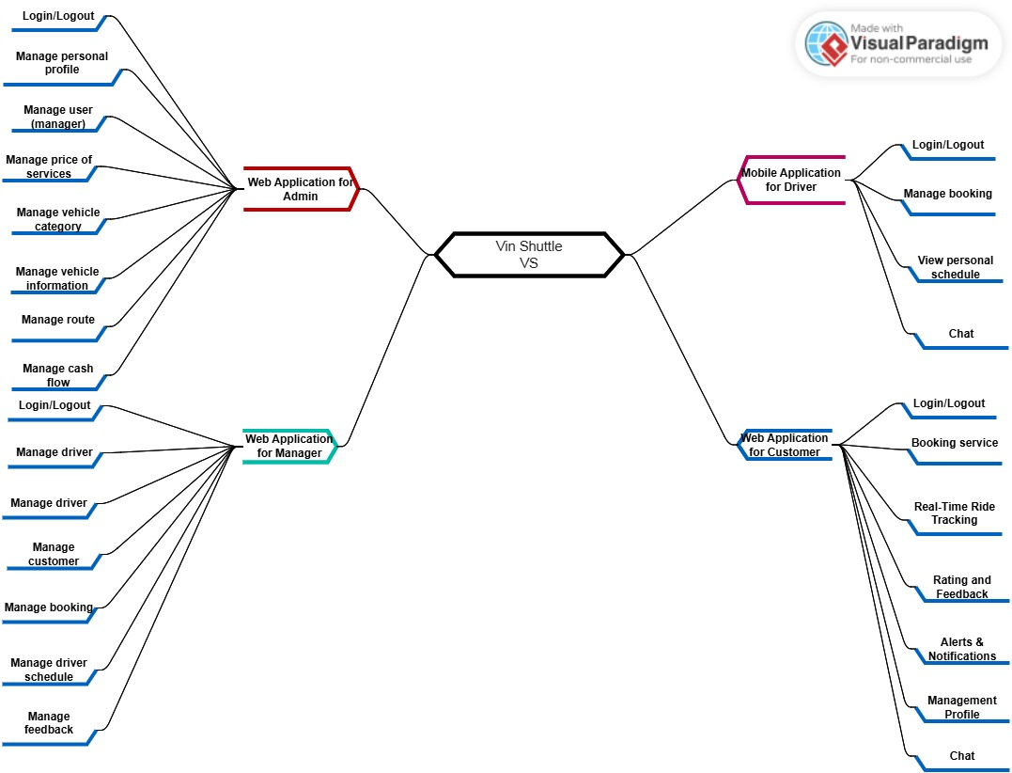

#### 6.2 Limitations

* **LI-1: Geographic Scope**: The VinShuttle service is limited to the VinHome Grand Park (VHGP) area. It does not extend to external locations outside the VHGP boundaries, ensuring the service is optimized for intra-area transportation.
* **LI-2: Service Availability**: The availability of VinShuttle services is dependent on the operational hours set by VinHome management. There may be limited service during off-peak hours or maintenance periods.
* **LI-3: Vehicle Capacity**: The electric shuttles have a limited passenger capacity, which may result in longer wait times during peak usage periods.
* **LI-4: Real-Time Tracking**: While real-time tracking is available, it is reliant on stable internet connectivity. Any disruption in connectivity may affect the accuracy of vehicle tracking.
* **LI-5: User Access**: The service is primarily designed for VHGP residents and may require users to verify their residency to access full features.
* **LI-6: Feedback and Support**: The feedback and customer support features are limited to in-app interactions, with no dedicated hotline for immediate assistance.